Lime-Lovers Angry: Justice Demanded

Mr. Young and Ms. Roberts are members of a secret organization investigating the discrimination of green in our society. The organization feels that the Skittles Company has been discriminating against green skittles.
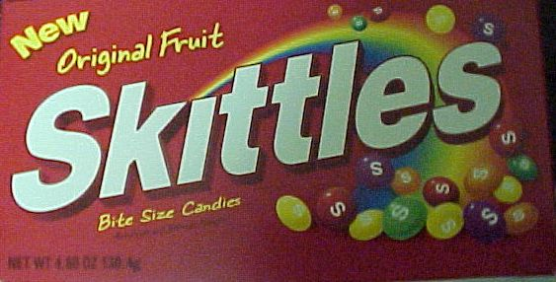
In the original flavour series there are 5 different colours. Mr. Young and Ms. Roberts took advantage of Hallowe’en this year to purchase several packages of Skittles in order to determine if there was a disproportional number of green Skittles. They opened, counted, and ate all of the Skittles to collect this data:

Package # | Red | Orange | Yellow | Purple | Green
1 | 2 | 1 | 4 | 3 | 3
2 | 2 | 3 | 3 | 5 | 0
3 | 4 | 3 | 1 | 2 | 4
4 | 1 | 5 | 4 | 2 | 2
5 | 4 | 0 | 4 | 3 | 2
6 | 3 | 1 | 5 | 3 | 2
7 | 0 | 3 | 4 | 2 | 3
8 | 0 | 4 | 5 | 1 | 3
9 | 4 | 0 | 1 | 4 | 5
10 | 2 | 1 | 2 | 2 | 5
11 | 1 | 3 | 3 | 4 | 3
12 | 3 | 2 | 3 | 4 | 2
13 | 3 | 4 | 1 | 2 | 4
14 | 5 | 4 | 2 | 1 | 2
15 | 3 | 3 | 0 | 2 | 4
16 | 1 | 2 | 3 | 4 | 2
17 | 3 | 3 | 4 | 3 | 0
18 | 2 | 2 | 2 | 2 | 4
19 | 4 | 0 | 3 | 2 | 4
20 | 5 | 3 | 1 | 2 | 2
21 | 2 | 2 | 4 | 3 | 1
22 | 1 | 5 | 3 | 1 | 3
23 | 2 | 3 | 3 | 2 | 4
24 | 2 | 1 | 4 | 5 | 1
25 | 3 | 5 | 2 | 4 | 0

Help them determine if Skittles is discriminating against green!

Open Microsoft Excel by double-clicking on the Excel icon in the “Common” group.
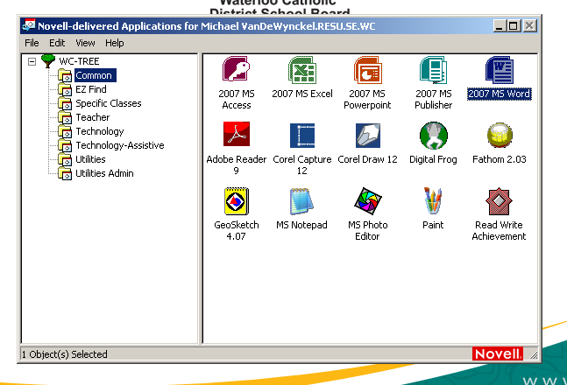

Enter the Skittles data by reproducing the chart from page 1.
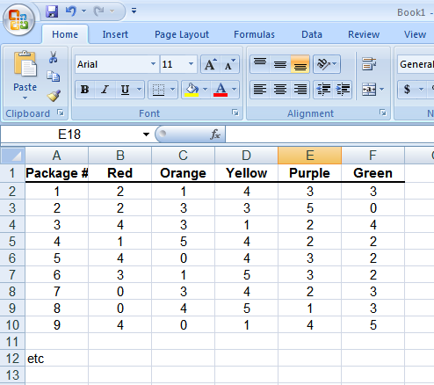

Let’s make some graphs!
Start by making a graph of the colour of skittles from the first package by highlighting the 5 pieces of data and clicking on the “Insert” tab and the column button. Select a 2D Clustered Column graph.
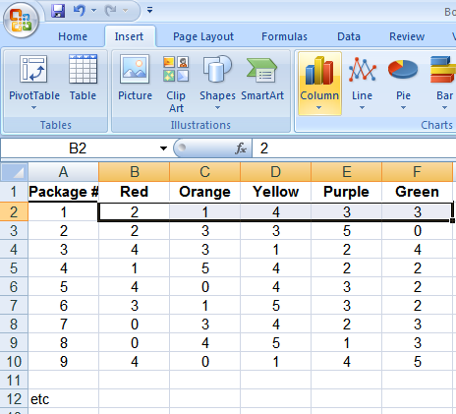

Label the axes and add a title to your graph by clicking your graph and then selecting the “Layout” tab.

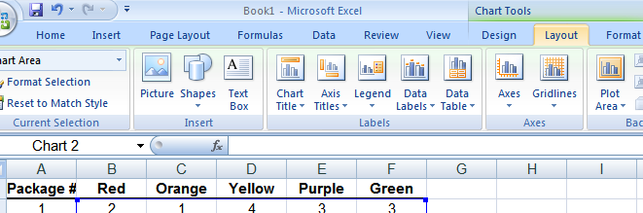
On the bottom of the graph (X axis) we want it to say Red, Orange, …. Instead of 1, 2 ,3, ….

Right click on the x axis and then click on “Select Data”
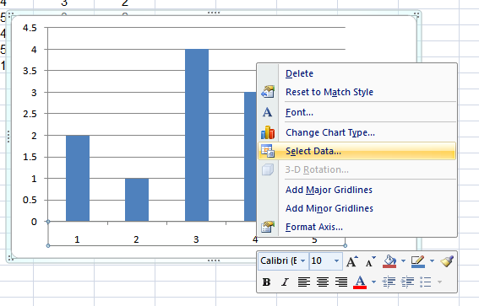

Click on “Edit” Horizontal (Category) Axis Lables
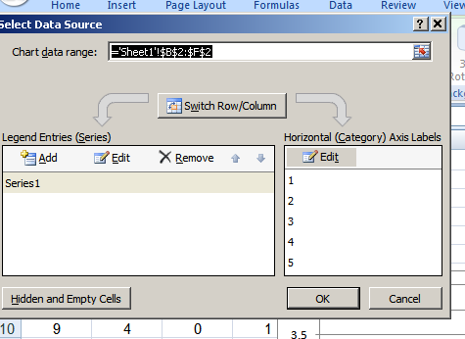

Click on this little button:
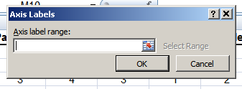

And then highlight Red, Orange, Yellow, etc and click “OK” twice!!

.

It’s probably not fair to just use one package of skittles as our test for discrimination against green. Instead of making 25 graphs (one for each package) let’s just add up all of the skittles and do one big graph!

Excel can add up numbers for you!

Underneath of all the data let’s type “Sums” and tell Excel to add up the total number of each colour of skittles.

In a spot under the reds type “=sum( “ and then highlight all of the red skittles. When you hit enter it should add up all the red skittles.

Repeat this for each of the five colours.

Now highlight the 5 totals and repeat the process for making a bar graph!
Start by clicking on the chart wizard button!

By looking at this graph is green being discriminated against?

Another way of determining discrimination might be to compare the average (mean) number of each colour of skittles. To determine the average number of each colour in the row under the totals let’s tell Excel to find the mean by typing “=AVERAGE(“ and highlighting all the red ones…. DO NOT HIGHLIGHT the total.

Do the averages show discrimination?

You can actually calculate medians and modes too! Type =MEDIAN( and =MODE( in the rows underneath it will do those calculations.

